|  |  |
| --- | --- |
|  | **E-Commerce Website**  **Technical Design Document** |
| |  |  |  |  | | --- | --- | --- | --- | |  | **Prepared By / Last Updated By** | **Reviewed By** | **Approved By** | | **Name** | Kushal Pendse (2225486)  Bhavik Bhatt (2225317)  Sahil Kakani (2225472)  Parth Yelne (2225347)  Vinodh Karri (2225267)  Billu Sisindri (2225488) |  |  | | **Role** | CSD Intern |  |  | | **Signature** |  |  |  | | **Date** | 05/01/2023 |  |  | |
|  |

Table of Contents

1.0 Introduction 3

1.1 Purpose of this document 3

1.2 Project overview 3

2.0 Solution Summary 3

2.1 Scope 3

2.2 Assumptions 3

2.3 Dependencies 4

2.4 Risks 4

3.0 Schematic Diagram 4

4.0 System Design 5

4.1 Proposed design 5

4.2 Component inventory 5

5.0 Database Design 5

5.1 Data Model 5

5.2 Tables Structure 5

6.0 Appendices 6

6.1 Glossary 6

6.2 Other 6

7.0 Terms & Conditions 6

8.0 Change Log 6

# Introduction

## Purpose of this document

The purpose of this document is to document the technical design, component details and Database design. This will also capture the scope, assumptions, risk, dependencies of this project.

## Project overview

The project aims to help the people buy products like clothes, electronic devices, home appliances and eatable packed products. The main idea is to provide a user friendly interface and a smooth shopping experience for the customers. The goal is to deploy the application website that can perform all activities, some of which are logging in successfully, able to add products in to the cart, view the cart, pay the total amount after any discounts applied, track the shipment, etc.

# Solution Summary

## Scope

1. E-commerce is one of the trending businesses in world. It is mainly about selling and buying the products in the online marketplace. Money transaction can take place in this business. E-commerce is easiest way to buy the required products through the online.
2. The scope of E-commerce is expanding the business day by day. Because of easy access to the internet in the world, people are spending more time on it for searching the products to buy on various E-commerce platforms with ease and in minimal time.
3. In the fast growing countries this type of business and technology is more important for the people. When compared with other countries, India is a high populated country and thus, has high number of internet users. Hence, the E-commerce business expansion becomes easy. Around the world more than 2.14 billion people are shopping through the E-commerce.

## Assumptions

1. The application should be user friendly so that the user should not face any issues understanding the app and also easily understand the same.
2. The application should have more users handling capacity at a single time and provide fast access to and from the database.
3. The application should support quick and seamless transaction.
4. User may access the application from any computer that has internet browsing capabilities and an internet connection.

## Dependencies

1. Existing Business Requirements, Rules, & Technical Specifications.
2. Existing Business Process Flows.
3. Product Pricing & Pricing Rule Sets.
4. Promotion and Promotional rules.
5. Shipping rules.

## Risks

1. Data privacy and security risks.
2. Platform downtime for updating servers or any other server issues.
3. Product damage while shipping and delivering.
4. Unauthorized Access by Hacking.

# Schematic Diagram

# System Design

## Proposed design

*<This sub-section shall elaborate the high-level design for this project>*

## Component inventory

*<This sub-section shall list the components for this project>*

# Database Design

## Data Model

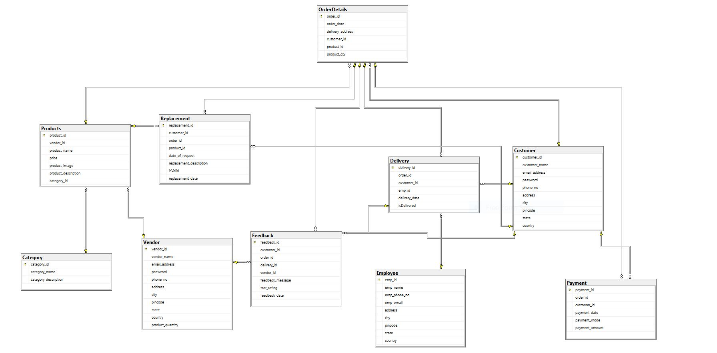

## Tables Structure

*<This sub section will describe the table structure>*

|  |  |  |  |
| --- | --- | --- | --- |
| **Column Name** | **Data Type** | **Length** | **Nulls** |
|  |  |  |  |

# Appendices

## Glossary

|  |  |
| --- | --- |
| **Acronyms** | **Definitions** |
|  |  |

## Other

# Terms & Conditions

***Disclaimer: Please do not circulate or distribute this document outside of Cognizant Network, We have a Zero Tolerance Policy. Kindly adhere to 100% Compliance at all times.***

# Change Log

*Please note that this table needs to be maintained even if a Configuration Management tool is used.*

|  |  |  |  |  |
| --- | --- | --- | --- | --- |
| Version Number | Changes made | | | |
| V2.0 | *<If the change details are not explicitly documented in the table below, reference should be provided here>* | | | |
| Page no | Changed by | Effective date | Changes effected |
| 5 | Kushal Pendse (2225486) | 13/01/2023 | Updated the Database Design Data Model |
|  |  |  |  |
|  |  |  |  |
|  |  |  |  |